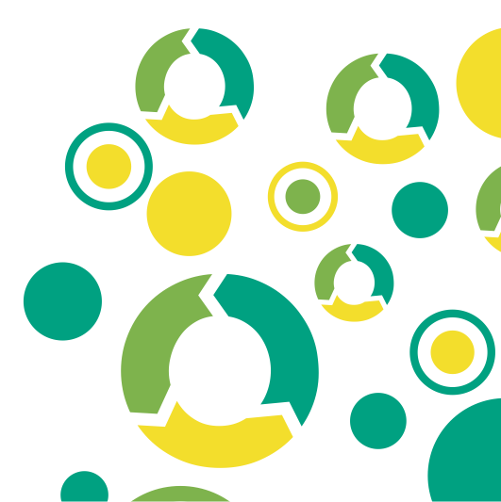




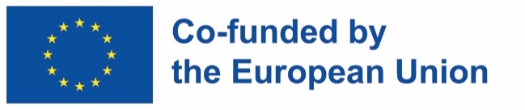
Funded by the European Union. Views and opinions expressed are however those of the author(s) only and do not necessarily reflect those of the European Union or the European Education and Culture Executive Agency (EACEA). Neither the European Union nor EACEA can be held responsible for them.
KA210-VET-B934985F

Worksheets 4
DETERMINING THE ENVIRONMENTAL
ASPECTS OF A PRODUCT

Worksheets 4: Determining the environmental aspects of a product

Worksheets 4.1: Choose an Environmental Impact Analysis Tool
Review the differences between the MECO matrix and Eco-indicators, and complete a computer-aided LCA analysis, and list or consider their advantages and disadvantages. Based on the recommendations for using the MECO matrix, Eco-indicators or a complete LCA analysis, choose the appropriate tool for environmental impact analysis.
Selected Environmental Impact Analysis Tool
Reasons

Worksheets 4.2: Define the purpose and scope of the environmental impact analysis
Specify the purpose of the analysis, the complexity level, and the product's name under consideration. Also specify the purpose of communicating the results.
 |  |  | YES / NO
Purpose of the study |  | Overview of opportunities for improvement in the product life-cycle
 |  | Overview of the activities in the product life cycle that contribute most to environmental impacts
 |  | Analysis of the environmental consequences of changes in certain processes in the life cycle of a product
 |  | Analysis of the environmental consequences of using secondary recycled materials instead of using primary raw materials
 |  | [Other...]
Level of complexity |  | Overview analysis
 |  | Simplified analysis
 |  | Full analysis
The system under consideration: |  | Product
Purpose of communicating results: |  | Internal
 |  | External
 |  | For customers
 |  | Publication
 |  | [Other...]
Select system boundaries, that is, to indicate which stages of the product life cycle will be included in the analysis:

Production stage: |  | Supply of raw materials
 |  | Transport
 |  | Production
Construction process: |  | Transport
 |  | Construction process – layouts
Application phase: |  | Use
 |  | Maintenance
 |  | Repair
 |  | Replacement
 |  | Renovation
 |  | Power consumption during use
 |  | Water use during use
Final life stage: |  | Degradation
 |  | Transport
 |  | Waste management
 |  | Disposal
Benefits and Burdens: |  | Reuse – Refurbishment – Recycling

4.3 Worksheets: Define a Function Unit
A functional unit combines a product function and a user scenario for a product.
Feature
What is the primary function of the product for the user?
Describe qualitatively and quantitatively?
Reference unit |  |  |  | (e.g. 1 kg, 1 m3, etc.)
Product group: |  |  |  | (e.g., wood products, etc.)
Required service period |  |  |  | (e.g. 10 years)
User Scenario
The product will most often be used in: |  | Mode of operation – during... |  | No. Hours per day |  | Number of days per week |  | Number of weeks per year
Location of use:
Use this form to specify the functional unit for your product or service. This ensures comparability of analyses and appropriate interpretation of LCA results.

Element | Description / Instruction | Enter a value
Name of the product/service | Name of the product or service analysed
Description of the primary function | What is the basic purpose or function? (e.g. "passenger transfer", "cleaning dishes")
Quantitative reference | How many units of function are provided? (e.g. 1 washed dish, 1 km of transport, 1 kg of product)
Duration of service life | How long or how many cycles does it take to use? (e.g. 5 years, 1000 cycles)
Frequency of use | How many times a day/week/year is the product used?
Location of use | Geographical region or conditions (e.g. EU, indoor space, household)
Quality standards/requirements | Norms, technical requirements, functional requirements (e.g. EN, ISO)
User Scenario | A brief description of how the product/service works in real life
Additional notes | Possible specifics affecting the analysis

Worksheets 4.4: Define the Life Cycle
Describe the stages in the product life cycle process diagram and write them down in the left column. Indicate the physical location of these phases in the right column. See example below.

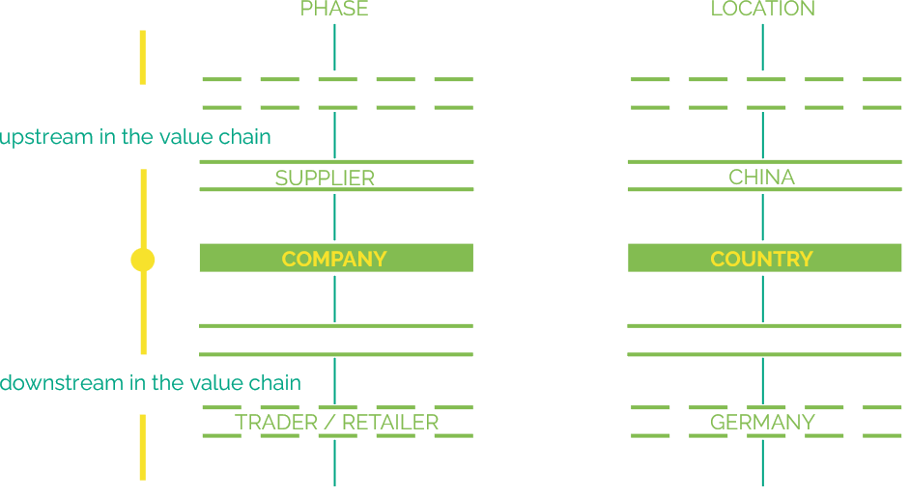

Worksheets 4.5: Inventory (inventory of material flows of individual processes in the life cycle)
The table below shows what data are required for the inventory of the material flows of individual processes according to the type of study:
Mandatory
optional due to minor importance or potential missing data

Worksheets 4.6: Environmental Impact Assessment

Assessment of environmental impacts by classifying the identified environmental impacts in the MECO matrix
- Determine the planning criteria for sustainability. Planning for sustainability to be included in the MECO matrix:
- Use of materials
- Energy consumption
- Solid waste
- Toxic emissions
- Social responsibility
- ...........
- ...........
- ...........

- Type the above criteria in the first column of the MECO matrix.
- Enter the previously identified life-cycle process stages in the first row of the MECO matrix.
- Fill in the MECO matrix and tick the fields with a relatively high impact.
 | Preparation of raw materials | ... | ... | ... | ... | ...
Use of materials
Energy consumption
Solid waste
Toxic emissions
Social responsibility
...
...
...

 | Type of study
 | MECO Matrix | Eco-indicator | Complete LCA
BEFORE THE APPLICATION PHASE
Supply of raw materials
Transport (to the factory)
Production
Transport (until assembly)
Assembly/assembly process
APPLICATION PHASE
Use
Maintenance
Repair
Replacement
Restoration
Energy use for operation
Water use for operation
END OF LIFE CYCLE
Degradation
Transport (for disposal)
Waste processes for reuse, recovery and/or recycling
Disposal



