





Funded by the European Union. Views and opinions expressed are however those of the author(s) only and do not necessarily reflect those of the European Union or the European Education and Culture Executive Agency (EACEA). Neither the European Union nor EACEA can be held responsible for them.
KA210-VET-B934985F

Worksheets 6
DEVELOPING A STRATEGY AND PREPARING
A SUSTAINABILITY PLANNING BRIEF

Worksheets 6: Developing a strategy and preparing a sustainability planning brief

Worksheets 6.1: Developing a Planning Strategy for Sustainability
- What are the two most crucial sustainability planning strategies for improvement based on the results of the MECO matrix? Mark them on the Strategy A wheel.
- What are the two most crucial sustainability planning strategies for improvement based on the results of selecting motivational factors for sustainability planning? Mark them on the B strategy wheel.
- What strategies will the company and the sustainability planning team focus on in the idea generation and concept development stages? Mark them on the C strategy wheel.

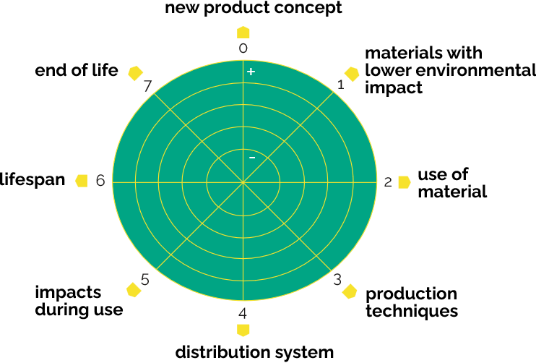

Worksheets 6.2: Preparing a Sustainability Planning Brief
- Prepare a brief overview (draft/brief) of sustainability planning.
A brief outline of sustainability planning is essential to understanding the objectives of the product sustainability planning process, as it provides the planner with all the information needed to develop and present solutions that meet the company's needs, expectations, and goals.
A good design of sustainability planning should provide the information presented in the table below. The column notes provide examples that should not burden you. While the complete worksheets are essential, we must pay particular attention and care to the draft in point 4.

1 Contact |  |  |  |  |  |  |  |  |  | Notes:
Company
Title
Tel/fax
E-mail
Web page
Person responsible for the project
2 Company profile
History | History |  |  |  |  |  |  |  |  | Social and technological development, products and business
Current state of the company | Brief description |  |  |  |  |  |  |  |  | Products/services:  Technologies for materials and costs
Current state of the company | Main customers and markets |  |  |  |  |  |  |  |  | Turnover  Geographical distribution  Products/Markets  Markets/prices
Current situation of direct competitors | Include the results of any benchmarking and/or any related information |  |  |  |  |  |  | Products/services:  Materials, technologies and costs
Motivational Factors of Sustainability Planning | Include the results of the analysis of motivational factors. |  |  |  |  |  |  | Internal  External
Keywords |  |  |  |  |  |  |  |  | Business Profile Keywords
3 Context/Problem/Opportunity

Elaborate on the problems/opportunities of the project, as well as the environment in which the final product is expected to operate. | (Short and clear description of the problem/opportunity) |  |  |  |  |  |  | Context may include:  Social, cultural, aesthetic, emotional, behavioural, economic, technological, industrial, political, geographical conditions, etc.
Target group | Identify the target audience of the project about the strategic goal of the company (consolidation of the position with major customers, creation of new markets) |  |  |  |  |  |  | For example, demographic and psychographic characteristics:  Age  Gender  Revenue  Employment  Lifestyle  Personal preferences  Specific cases  Nationality
Keywords |  |  |  |  |  |  |  | Keywords for achieving the objectives of a strategic plan that supports the development of a sustainability planning project
4 Draft Sustainability Planning
Product description  (product design or refurbishment) |  | Identify the problem/product and how you plan to solve it with sustainability planning. |  |  |  |  |  | At this stage, the description of the measures envisaged should not be too specific to allow for as many possible solutions to the problem as possible.
List of attributes |  | It creates a list of criteria, arranged according to their importance, so that they can later be compared with the proposed solution.  In the case of product refurbishment, include the results of the preliminary analysis of the reference product. |  |  |  |  | Criteria may include:  Appearance  Function  Ergonomics  Form  Production  Environment  Security  Technical feasibility  Maintenance  Reliability  Standardisation  Utility  Life cycle  Components  Packaging  Transport  Sale  Price  Brand  Social value
Visual inspiration |  | Graphical information is a potential source of inspiration for developing a feasible solution. |  |  |  |  | Graphical information may include:  Sketches  Snippets  Photos  Movies  Materials  Textures  Patterns  Colors  Landscapes  Architecture  Technique  Art  Details  Perception  Emotions  Trends  Functionality  Shapes  Literature

5 Budget
Funds for the project | Specify the budget allocated to the project (even if it is impossible to determine this, it is necessary to have an idea of the significance of the project and the announced investment). | This information helps the sustainability planning team deliver more realistic solutions.
Timeline and deadline | Provide a project plan. | Fundamental information for planning the development of the project.
Project team and support team |  | Specify the project team and support team and their functions within the project.
Consulting/external support |  | Specify the needs for external support in the project.



