
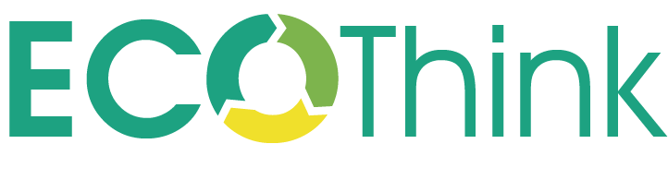



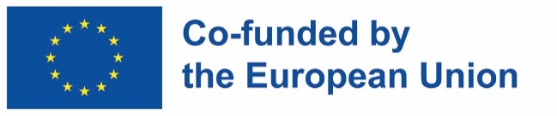
Funded by the European Union. Views and opinions expressed are however those of the author(s) only and do not necessarily reflect those of the European Union or the European Education and Culture Executive Agency (EACEA). Neither the European Union nor EACEA can be held responsible for them.
KA210-VET-B934985F

Worksheets 7
SETTING UP A PROJECT TEAM
AND PLANNING A SUSTAINABILITY PROJECT

Worksheets 7: Product Improvement Ideas

- Identify a problem to conduct a creativity session:

- Organise a creativity session and suggest possible improvements using selected planning strategies for sustainability. Collect noticeable possible improvements during the analysis of the MECO matrix and the motivational factors of planning for sustainability.
Possible improvement
1
2
3
4
5
6
7
8
9
10
11
12
13
14

- What criteria should be included in the prioritisation of possible improvements?
Idea | Criterion 1 | Criterion 2 | Criterion 3 | Criterion 4 | Criterion 5 | Criterion 6 | Action plan (K, S or D) | Note
 | Environmental benefits | Social benefits | Financial benefits | Technical feasibility | Market opportunities | ..........
1
2
3
4
5
6
7
8
9
10
11
12
13
14

- Rank your options based on your assessment of time feasibility – short-term (K), medium-term (S), or long-term (D).
The purpose of this matrix is to evaluate the product improvement ideas that have arisen in the search for ideas for improvement, in terms of their technical, financial, market and environmental feasibility.
This matrix serves the sustainability planning team and the company's top management as a basis for deciding whether certain possible improvements should be made in the short, medium or long term, or whether an option should be discarded. In some cases, additional research is needed to validate a particular idea.
These worksheets can be used qualitatively in the context of a discussion by the sustainability planning team and support groups, or they can be used after several in-depth studies using environmental analysis, life cycle costing, or market analyses presented in the manual. The assessment can be carried out in-house or with external professional support, depending on the complexity of the ideas and the team's workforce. In any case, it is essential to note all the assumptions behind each scoring. Subjectivity is not a problem if it is managed transparently.
Depending on the draft design for sustainability, additional criteria can be added (e.g., aesthetic, ergonomic, etc.).
For qualitative evaluation, we take into account aspects such as:
- Technical feasibility: Are the required technical resources available in the company? Are there risks to reducing the quality of the product? Are the necessary new raw materials easily accessible? Are new technologies tested and available on the market? Are the suppliers known and trustworthy? Is new equipment necessary? Is new staff necessary (or new responsibilities)?
- Financial feasibility: How much investment is required? What is the financial impact of possible improvements throughout the life cycle?
- Market feasibility: Does the idea have a significant impact on the market?
- Environmental feasibility: Are we achieving material and energy savings? Is there an increase or decrease in waste and emissions? There are often trade-offs, as planning for sustainability brings both disadvantages and advantages from an environmental point of view. Often, rough assessments in relation to energy and raw material flows can be carried out at no significant cost, and sufficient information is quickly available to assess the environmental optimum. This can be confirmed in a rigorous way through a quantitative assessment of the life cycle.
Other possible fields in the array can be as follows:
- Timeline for implementation: The sustainability planning team needs to determine whether the option is part of the short, medium or long-term implementation plan. This timeframe, of course, is dictated by the company's overall strategy.
- Level of analysis: Here, the team is determined by the sufficiency of the analysis performed, or whether the planning options for sustainability need to be further explored before a decision can be made about their implementation.
- Note: There is also a box to enter the views that justify the decision, or we can enter any relevant comments.

After evaluating all options, the team must select ideas that will be elaborated in the new product concept.

 | Evaluation matrix
Possibility of improvement | Feasibility |  |  |  |  | Timeframe for implementation | Robustness of the analysis | Notes
Possibility of improvement | Technical | Economic |  | Environmental | Market | Timeframe for implementation | Robustness of the analysis | Notes
Option 1
Option 2
Option 3
Option 4
Option 5
Option n
Assessment | Feasibility |  | "0" - Negative or Not Workable  "=" – Neutral  "1 to 5" – Positive or very positive
Assessment | Implementation |  | "K" – short-term "S" – medium-term "D" – long-term
Assessment | Robustness |  | "1 to 5" (from low robustness to high robustness)



